P R E S S R E L E A S E

Election of the Steering Committee at the IO-Link Members Assembly 2025
Presentation of the future vision and strategic direction of IO-Link

Karlsruhe, June 03rd, 2025: On May 22, 2025, the IO-Link Community gathered in Bad Soden for this year's Members Assembly. A key event was the regular election of the Steering Committee, which plays a decisive role in shaping the technological future of the standard. A complete list of the members of the Steering Committee is available on the new IO-Link website (www.io-link.com).

Another highlight was the presentation of IO-Link's vision and mission. The goal is to consolidate the standard worldwide as the leading enabler for industrial IoT and digitization processes. In addition, the current roadmap was presented, outlining the strategic path for future developments, innovations, new functions, and security aspects. With this roadmap, IO-Link will continue to play a leading role in industrial automation and drive forward the cooperation of all partners in digitization.

Another important item on the agenda of the Members Assembly was the presentation of the future development of IO-Link packages for maintenance updates. Package 2025 serves as a pilot project for the newly defined package process, which is intended to make the creation, updating, and management of IO-Link standards more efficient and transparent. The goal is to establish a clear structure and standardized process to make the further development of the standard even more targeted and flexible.

Another focus was on the increasingly important security requirements. Work on the “IO-Link Secure Deployment Guideline” was presented to help end users with secure implementation. The “Secure Design and Development Guideline for IO-Link Devices” is still under development. It will contain recommendations for the secure design and development of IO-Link products to meet increasing security requirements.

In order to provide all participants with comprehensive information, the leaders of the working groups also reported on the current status of their groups' activities. This year's Members Assembly confirmed once again that IO-Link is a vibrant, committed, and global community in automation technology.

***

Foto: The IO-Link Steering Committee was newly elected at the Members Assembly in Bad Soden.

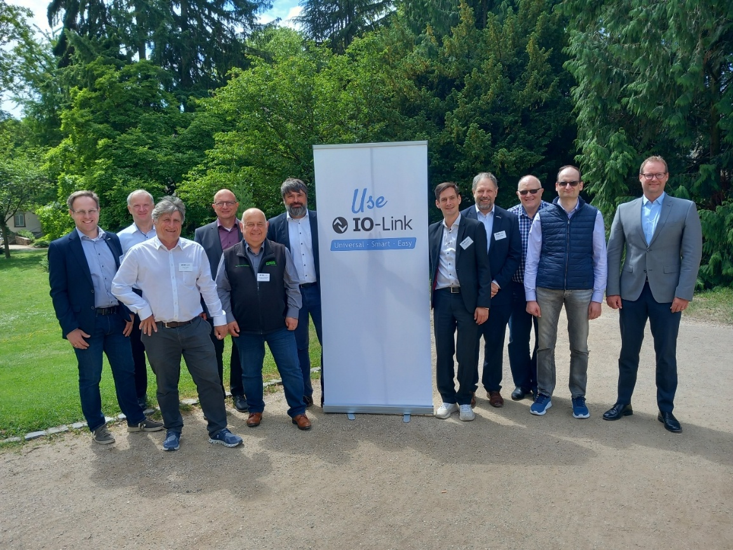

Press contact:
PI (PROFIBUS & PROFINET International)
PROFIBUS Nutzerorganisation e. V.
Barbara Weber

Ohiostr. 8

D-76149 Karlsruhe, Germany
Phone: +49 7 21 986197 49

Fax: +49 7 21 986197 11
Barbara.Weber@profibus.com
http://www.PROFIBUS.com

