P R E S S R E L E A S E

IO-Link Interop Workshop 2025 in Bad Soden:
Record attendance and focus on IO-Link Safety

Karlsruhe, Germany on October 01, 2025: On September 23–24, 2025, another IO-Link Plugfest took place in Bad Soden. With almost 125 participants, the event was completely booked out. Around 60 different companies from all over the world took the opportunity to test their IO-Link products on site in a practical environment.

International interest was particularly high this year, with representatives from countries such as Hungary, Luxembourg, Switzerland, Poland, China, Denmark, Great Britain, the USA, the Netherlands, and the Czech Republic traveling to the Plugfest. During the Interop Workshop, a new test system for masters and devices was successfully audited by a Chinese test center and then immediately tested in use by numerous participating device manufacturers.

In addition to standard IO-Link technology, the focus was also on new topics such as IO-Link Wireless, profile implementations, system integrations, and IoT connections via JSON REST API. A particular highlight was the presentation and testing of the IO-Link Safety Demo—with new functions and additional devices from various manufacturers—an important step in the further development of the technology.

Besides the technical tests, networking was also a focal point: the intensive exchange between developers, manufacturers, and IO-Link experts provided valuable impetus and inspiration for future projects. Many participants took the opportunity to make new contacts, deepen existing partnerships, and share practical experiences with each other.

The workshop offered participating companies the chance to test their devices and software solutions for interoperability and ensure that they work seamlessly with products from other manufacturers. Test runs during the development phase provided important insights and clarified open questions in direct exchange with international IO-Link experts.

“The strong response and the large number of new products clearly show that IO-Link plays a central role in industrial communication worldwide,” summarized Frank Moritz, working group leader for IO-Link Quality & Technology.

It is already clear today that the success story will continue – the next IO-Link Interop Workshop is scheduled for fall 2026 and will once again provide an opportunity for comprehensive testing, intensive exchange of experience, and the continuation of technological development.

***

Image: Full house at the IO-Link Interop Workshop 2025 in Bad Soden: Almost 125 participants from around 60 companies took advantage of the opportunity to test, network, and exchange ideas.

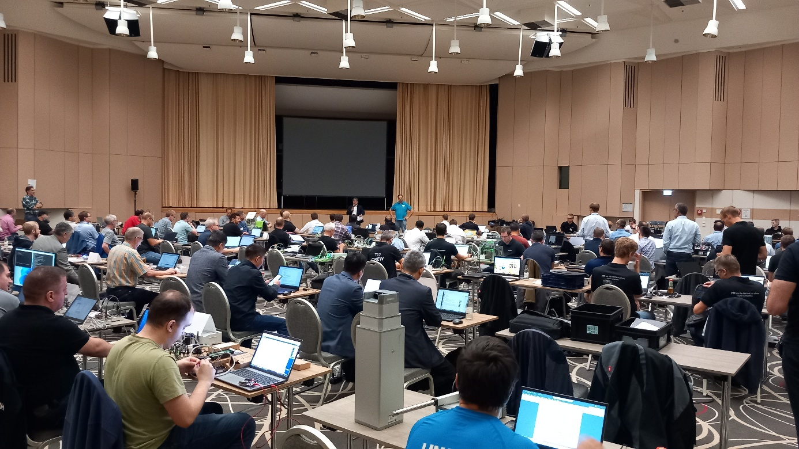

Press contact:
PI (PROFIBUS & PROFINET International)
PROFIBUS Nutzerorganisation e. V.
Barbara Weber

Ohiostr. 8

D-76149 Karlsruhe, Germany
Phone: +49 7 21 986197 49

Fax: +49 7 21 986197 11
Barbara.Weber@profibus.com
http://www.PROFIBUS.com

