P R E S S E M I T T E I L U N G

Get Together for Robotics 2025
Successful networking and discussions at the largest
international robotics conference for executives and experts

Karlsruhe, 08th December 2025: This year, robotics enthusiasts (users, PLC manufacturers, organizations, startups, and universities) once again gathered at the ‘Get Together for Robotics’ conference to discuss the latest developments in the industry. Around 170 participants, including many decision-makers, accepted the invitation to Erlangen (Germany) in November, both online and offline. This means that ‘Get Together for Robotics’ has grown once again and established itself as the leading robotics event for experts and decision-makers in the industry. In addition to trends and exciting innovations in robotics, the two-day networking event also focused on the future role of AI in robot applications. It became clear that, in the future, collaboration across company boundaries will be more necessary than ever. This requires a new mindset, but also a greater willingness to take risks. This is particularly important considering the current challenges in the market.
The ‘Get Together for Robotics’ was organized by PI (PROFIBUS & PROFINET International), which has been promoting the standardization of technologies across company boundaries for many years. A few years ago, PI was also entrusted with the development, expansion, and maintenance of the SRCI (Standard Robot Command Interface) data and command interface standard. The data interface is a milestone on the road to faster and easier cross-manufacturer integration of robots into production. There were also numerous presentations on this topic at the event.
Exciting discussions about the future of industrial automation
This year, two high-profile roundtable discussions once again provided interesting insights into the future of robotics and how it can be implemented more quickly and easily.

“Women in Robotics: Leading, Engineering, and Shaping the Future.”
On the first day, Roberta Tanzariello, Platform Lead Robotics and Digital Tools at Rockwell Automation, Susanne Nördinger, Head of Ecosystem Success EMEA at Universal Robots, Kateryna Portmann, Co-Lead Swiss Chapter at Women in Robotics Switzerland, and Dr. Ing Caren Dripke, Head of Robotics Department at Lorch Schweißtechnik GmbH, discussed the topic “Women in Robotics: Leading, Engineering, and Shaping the Future.” They began by exploring the question of why so few women still choose to enter the robotics industry. Other key topics of discussion included how to bring robotics technologies to market more easily, how regulatory and ethical considerations will impact the entire robotics ecosystem in the coming years, and how robotics companies can promote greater cross-industry collaboration to drive innovation.

Roberta Tanzariello | Global Platform Lead Robotics and Digital Tools | Rockwell Automation
“The advancement of robotics and digital tools is no longer driven by isolated innovation - it’s powered by collaboration across disciplines, industries, and perspectives. The future of robotics will be shaped not only by technological breakthroughs, but by how effectively we coordinate efforts to make those breakthroughs accessible, scalable, and impactful. As complexity grows, the focus shifts to simplifying deployment and reducing integration costs. These efforts accelerate the development of intelligent, easy-to-use systems that meet real-world needs and drive sustainable innovation in industrial automation.”
Kateryna Portmann | Co-Lead | Women in Robotics Switzerland
“The continued interest in shared platforms for robotics innovation shows how vital it is to bring together diverse perspectives—from manufacturers and startups to research institutions. Events like this help ensure that robotics solutions remain relevant, inclusive, and grounded in real-world needs.”

Next-Gen Innovators: Redefining Industrial AI & Robotics
On the second day, Alexander Mayr, Chief of Staff at Neura Robotics GmbH, Paul Maroldt, co-founder and Head of Robot Engineering at RobCo GmbH, Stephan Hotz, Chief Product & Technology Officer at Wandelbots GmbH, and Jens Kotlarski, CEO and founder of voraus robotik GmbH, discussed the opportunities offered by AI and its future role, e.g., whether AI can really increase the speed of automation and robotics. There were also valuable insights for young companies, such as the challenges a start-up has to face today.

Paul Maroldt | Co-Founder & Head of Robot Engineering | robCo
"While many are excited about how AI will shape the future of robotics, manufacturers today face an urgent and growing challenge: the shortage of skilled workers. Without automation, this gap will only widen, threatening productivity and growth. By combining AI and robotics in adaptable systems that are easy to implement and operate today, companies can automate the ordinary - so people can focus on the extraordinary.“
Stephan Hotz | CPTO | wandelbots
“No single company will solve the challenges of robotics and automation alone. Our industry faces the task of bridging complexity, driving harmonization, and making automation more accessible to all. Collaboration and openness are what will turn today’s fragmented ecosystem into a truly connected one - that’s where real progress begins.”

SRCI: Easier use of robots for greater flexibility in production
The ‘Get Together for Robotics’ was launched several years ago when work began on the SRCI (Standard Robot Command Interface) uniform data and command interface in PI (PROFIBUS & PROFINET International). This interface allows robot programs to be written entirely in the PLC by calling up the robot functions and reporting the necessary robot status information back to the PLC. The interface is the basis for easier use of robots and thus more flexible production. For users, this means that they need much less detailed knowledge about the respective robot manufacturers, the handling, and the range of functions of the robot handheld device. For robot manufacturers, this means that they can make their robots accessible to the large pool of PLC experts.

Around 30 members (PLC and robot manufacturers, universities) are now involved in the working group. Eight manufacturers have now launched products with the SRCI data interface, and further products from other manufacturers are expected later this year. The ‘Get Together for Robotics’ thus provided the ideal opportunity to exchange ideas about the practical use of SRCI and experiences with the still young data interface.

***

Foto: Discussing the potential and challenges arising from the combination of AI and robot technology at the Robotics Executive Roundtable “Trends in Robotics” led by moderator Christine Brunner: From left to right: Alexander Mayr, Chief of Staff at Neura Robotics GmbH; Paul Maroldt, co-founder and Head of Robot Engineering at RobCo GmbH; Stephan Hotz, Chief Product & Technology Officer at Wandelbots GmbH; and Jens Kotlarski, CEO and founder of voraus robotik GmbH.
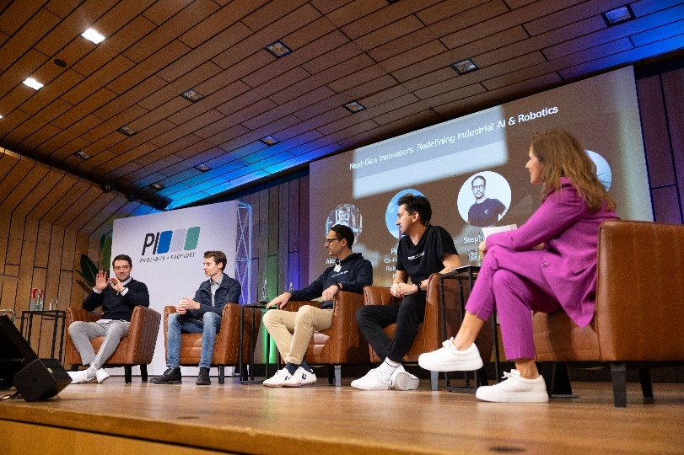

Pressekontakt:
PI (PROFIBUS & PROFINET International)
PROFIBUS Nutzerorganisation e. V.
Barbara Weber

Ohiostr. 8

D-76149 Karlsruhe
Tel.: 07 21 /986197 - 49

Fax: 07 21 / 986197 - 11
Barbara.Weber@profibus.com
http://www.PROFIBUS.com

