P R E S S R E L E A S E

PROFINET Plugfest 2026:
Strong Momentum Toward Secure Industrial Communication

Cross-vendor collaboration and practical SXP validation
are driving the finalization of the PROFINET 2.5 specification

Karlsruhe – 15. April 2026: The PROFINET community continues to drive progress toward secure industrial communication: At the third PROFINET Security Plugfest on March 24–25, 2026, at the technical university of applied sciences OTH Amberg-Weiden, organized by PI (PROFIBUS & PROFINET International) and aia automations institut GmbH, leading automation providers tested the latest security features.

The central focus was the Service eXchange Protocol (SXP), the foundation of PROFINET Security. Early SXP implementations at Layer 2 and Layer 3 demonstrated how the protocol enables secure and interoperable communication across various automation environments.

The Plugfest confirmed the high level of maturity of the new security technologies. This demonstrated stable AR establishment as well as device access via SXP across multiple manufacturers. Multi-controller scenarios, as well as Layer 2 and Layer 3 scenarios, also functioned reliably. Robust operation was also evident in shared-device and parallel-protocol configurations. Furthermore, immediately actionable technical insights were gained that contribute to further optimization.

All SXP implementations were developed in parallel with the finalization of the PROFINET 2.5 specification. The insights gained are directly incorporated into the standardization process and accelerate the path toward a secure, certification-ready solution. Participating companies used the plugfest to immediately clarify technical questions, coordinate implementations, and define expectations for certification. The feedback gathered enhances usability, diagnostic functions, and test coverage along the security roadmap.

The PI certification system provided important support with the PROFINET Trial Test & Security Bundle, which provides early test cases and tools for security extensions, thereby creating a uniform technical basis for SXP testing. In addition, a new SXP demo provided reference examples, source code, and templates that significantly accelerated integration.

The next Security Plugfest will take place in September 2026. With each Plugfest, PI reinforces its goal of providing secure, interoperable, and future-proof industrial communication—and further expanding PROFINET as the reliable backbone of tomorrow’s networked production.

Visitors to the Hannover Messe can obtain comprehensive information on PROFINET and the new security features at the PI booth in Hall 27, Booth D37.

***

Foto: Twenty-six participants from nine companies took part in the PROFINET Security Plugfest to thoroughly test SXP and the latest PROFINET security features and ensure interoperability.

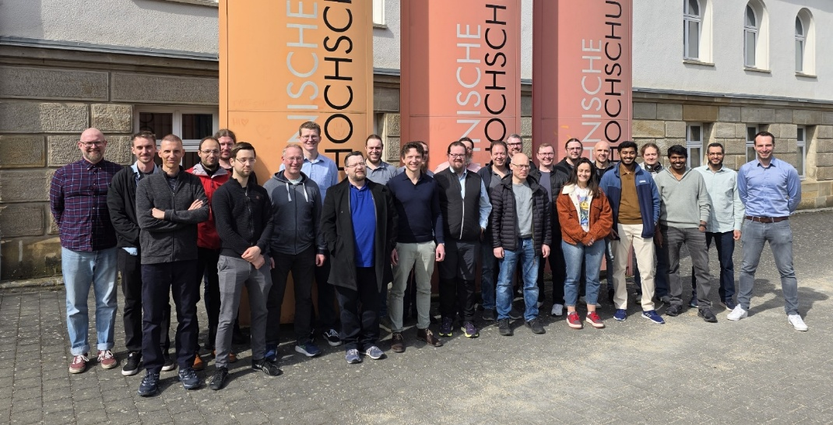

Press Contact:
PI (PROFIBUS & PROFINET International)
PROFIBUS Nutzerorganisation e. V.
Barbara Weber

Ohiostr. 8

D-76149 Karlsruhe, Germany
Phone: +49 7 21 986 197 49
barbara.weber@profibus.com
http://www.profibus.com

