P R E S S E M I T T E I L U N G

Successful PROFINET Security Plugfest Demonstrates
Progress in Secure Communication
PI (PROFIBUS & PROFINET International) strengthens industrial cyber security

Karlsruhe - Germany, October 15th, 2025: PI (PROFIBUS & PROFINET International) can proudly report on an extremely successful PROFINET Security Plugfest, which took place from 30 September to 1 October 2025 at the East Bavarian Technical University (OTH) Amberg-Weiden. Hosted by aia automations institut GmbH and the East Bavarian Technical University (OTH) Amberg-Weiden, leading technology providers and device manufacturers from the automation industry gathered to intensively test the latest PROFINET security features and ensure interoperability.

The plugfest focused on the further development and validation of critical security mechanisms that are essential for protecting modern industrial networks. Among other things, the participants tested Security Association Management (SAM), comprehensive tests for establishing secure communication connections using the latest Transport Layer Security (TLS) version, the Protection/De-Protection Protocol Class (PRO), advanced tests for cryptographic security of cyclic and acyclic communication, and interoperability tests using the PROFINET-specific Remote Service Interface (RSI) for connection establishment and record-based communication.

The participating companies made remarkable progress in validating PROFINET security. For example, security tests involving multiple controllers and multiple end devices were successfully carried out, and proof of the secure establishment of application relations (AR) via RSI was provided.

These extensive tests were based on the current development status of the certification test for this scope. These findings and developments are now being made available to the entire PI community in the form of trial bundles, allowing all members to benefit directly from the progress made.

The plugfest underscores PI's ongoing efforts to advance standards for industrial communication and continuously improve cybersecurity in automation technology. The results of this Security Plugfest represent a decisive step towards securing industrial automation networks. The successful collaboration of members in validating state-of-the-art security technologies reinforces PI's commitment to establishing PROFINET as the most secure and reliable communication solution for Industry 4.0.
***

Graphic: Twenty-four participants from nine companies took part in the PROFINET Security Plugfest to thoroughly test the latest PROFINET security features and ensure interoperability.

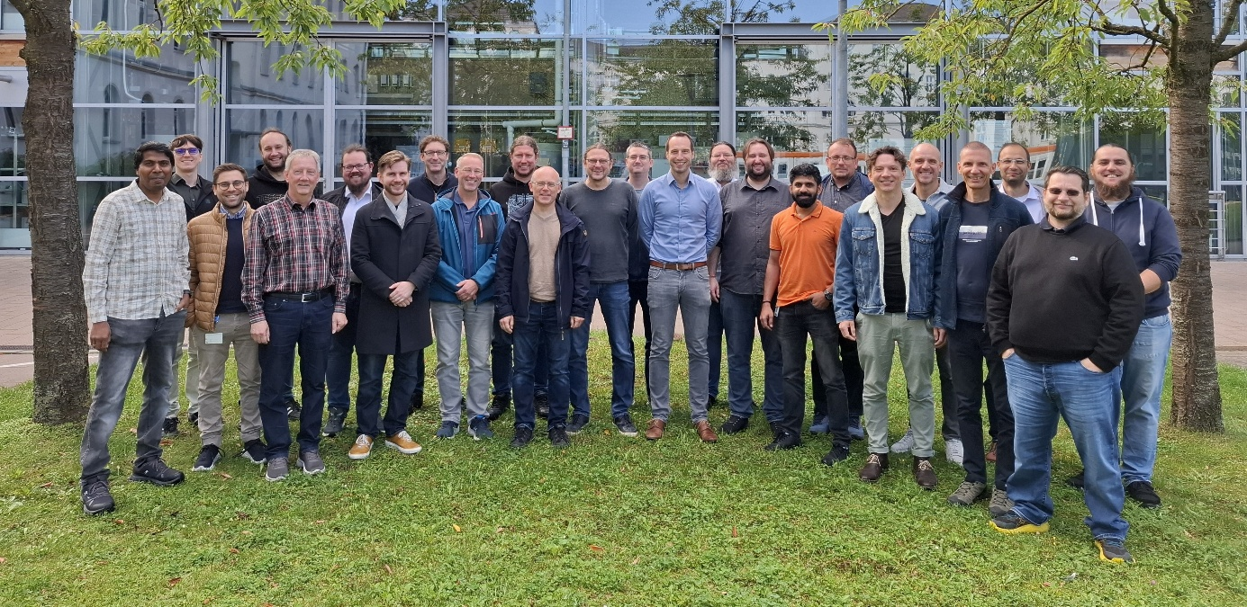

Press contact:
PI (PROFIBUS & PROFINET International)
PROFIBUS Nutzerorganisation e. V.
Barbara Weber

Ohiostr. 8

D-76149 Karlsruhe, Germany
Phone: +49 7 21 986 197 49
barbara.weber@profibus.com
http://www.profibus.com
This press release is available for download at www.profibus.com.

