PRESS RELEASE

New PROFINET Security Design Guideline Published

Nuremberg, November 26, 2025: PI (PROFIBUS & PROFINET International) has published a new planning guideline for PROFINET Security. The "PROFINET Design Guideline Security" is now available to all PI members and provides another valuable contribution to achieving the necessary OT security in production facilities. This is an important topic for all manufacturing companies!

The latest PROFINET specification defines the essential technical cybersecurity features of the PROFINET protocol, which are already being implemented in the protocol stacks. The above-mentioned guideline, on the other hand, describes the steps required to plan a production plant in terms of OT security. It is aimed at planners, commissioning engineers, and operators of production plants and was initially written in English. A German version will follow.

The guideline provides stakeholders in the cyber security process with basic information on how to design the plant and what points to consider during commissioning and operation – valuable support for all cyber security experts in manufacturing companies. In addition to general information on the security planning process, PROFINET-specific information is also provided. This information can be found in the appropriately labeled chapters.

The author of the guideline, Prof. Dr. Karl-Heinz Niemann, who has been committee chair at PI for many years and is responsible for the highly established PROFINET planning, installation, and acceptance guidelines, explains the significance of the guideline: "By publishing the guideline early, we are giving the PROFINET community the opportunity to address PROFINET security at an early stage and to plan the processes in their companies accordingly. Even though some chapters still lack detailed information, I see this as a good introduction to the topic before products become available on the market. We will fill in the remaining gaps as soon as it becomes clear how manufacturers have implemented certain functions in their products."
The guideline can be downloaded free of charge by all PI members at https://www.profibus.de/security .

Graphic: With the publication of the "PROFINET Design Guideline Security" document, PI (PROFIBUS & PROFINET International) is making a further contribution to supporting OT security in production facilities.
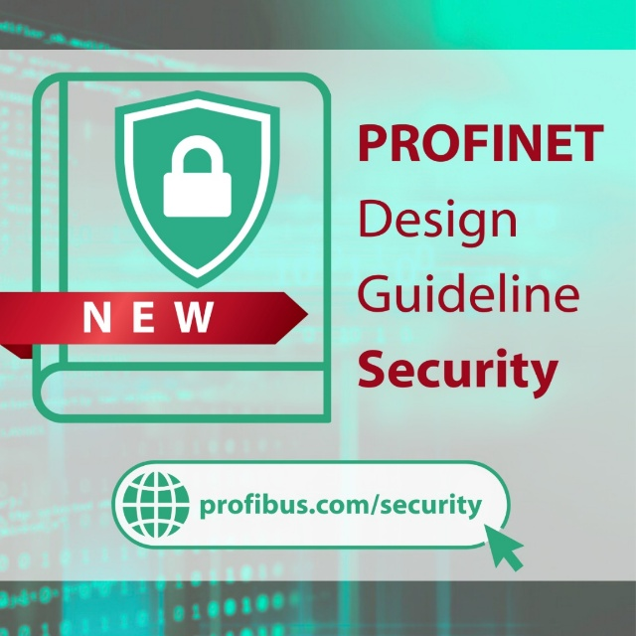

Press contact:
PI (PROFIBUS & PROFINET International)
PROFIBUS User Organization e. V.
Barbara Weber

Ohio Street 8

D-76149 Karlsruhe
Tel.: 07 21 /986197 - 49
Barbara.Weber@profibus.com
http://www.PROFIBUS.com

