P R E S S E M I T T E I L U N G

PROFINET Sets Standards in Industrial Ethernet Security
Market leadership strengthened by consistent security strategy

Karlsruhe, 05. August 2025: A recent analysis by the market research institute Omdia confirms once again that PROFINET is the leading technology in the field of industrial Ethernet protocols. In addition to its widespread adoption, PROFINET is particularly convincing due to its consistent focus on security - a decisive factor in times of increasing networking and digital threats.

With the publication of the PROFINET Specification V2.4 MU6, PI (PROFIBUS & PROFINET International) is sending a strong signal for security by design. The new version contains comprehensive definitions for Security Class 2 and 3, which are specifically tailored to the requirements of modern industrial systems. These security mechanisms ensure robust networks that are protected against both external attacks and inadequate access controls.

The accompanying technologies, such as GSDML, and the certification processes are also being continuously developed to ensure the highest level of integrity and trustworthiness. Developers benefit from clear specifications and a stable basis for secure system architectures.

PROFINET shows its strength not only in the breadth of applications - for process automation, factory automation, high-end motion control with IRT, with integration of IO-Link or with Ethernet-APL and Ethernet-SPE - but also in the depth of safety and security concepts.

Close coordination with other PI technologies and the involvement of over 1,000 experts in the working groups ensure that security aspects are identified and addressed at an early stage.

The market leadership of PROFINET is not only confirmed by Omdia, but also by other independent studies, such as the annual analysis of the industrial network market by HMS Networks or the market study “Industrial Communication / Industry 4.0 2025” by Michaela Rothhöft.

***

Graphic: Market shares of industrial Ethernet protocols according to an Omdia study.

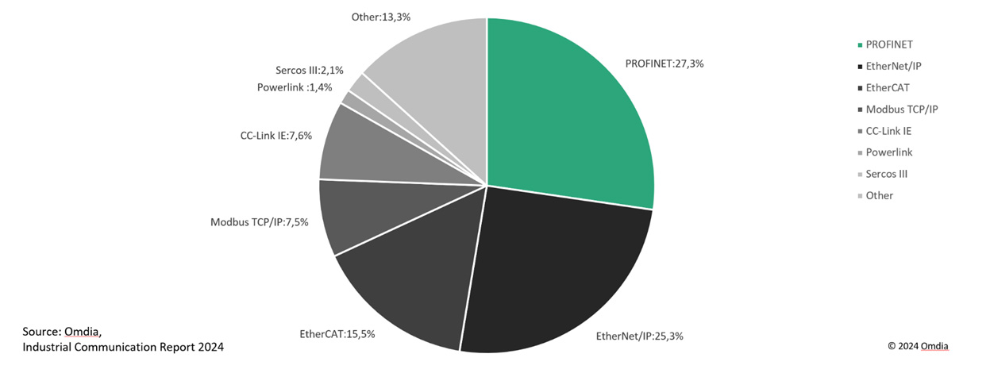

Pressekontakt:
PI (PROFIBUS & PROFINET International)
PROFIBUS Nutzerorganisation e. V.
Barbara Weber

Ohiostr. 8

D-76149 Karlsruhe
Tel.: 07 21 /986197 - 49

Fax: 07 21 / 986197 - 11
Barbara.Weber@profibus.com
http://www.profibus.com
Der Text dieser Pressemitteilung steht unter www.profibus.com zum Download bereit.

