P R E S S R E L E A S E

MTP Activities Have Picked-up Speed

Karlsruhe, Germany – November 15, 2023: PI (PROFIBUS & PROFINET International) has been chosen as the host of MTP technology by NAMUR and ZVEI, and cooperative work on the Joint Working Groups (JWG) has already begun. The next goal is to revise and speedily provide the already available versions of specification documents on the topics of modeling, HMI integration and process control.

To ensure implementation quality, the JWG “MTP Quality” has been mobilized. This working group’s initial task is to define the requirements and marginal conditions of certification tests which will form the basis for implementation in testing tools and the execution of certification tests.

The JWG “Runtime Interoperability” will create additional MTP specifications for ensuring the interoperability of MTP modules at runtime. At the same time, activities for the international standardization of MTP as the IEC 63280 standard have commenced. Coordination of specification work, quality assurance and international standardization is being handled by the cooperation partners on the Steering Committee founded for this purpose.

Marketing activities for the early establishment of MTP technology on the market have also begun. For example, PI has already presented a new multi-vendor live demo at the most recent Hanover Fair and this year’s SPS show. This demo illustrated the integration of so-called Process Equipment Assemblies (PEA) into a higher-level control or SCADA system of the Process Orchestration Layer (POL) in just a few minutes. This has a positive effect on efficiency in engineering.

MTP was also presented with resounding success for the first time at a trade show outside Germany in October 2023. Industrial Transformation ASIA-PACIFIC (ITAP) is the top platform for digital industry and intelligent production in the Asia-Pacific region and took place in Singapore. Together with NAMUR and ZVEI, PI was represented at a joint MTP-themed stand. In addition to a host of companies which presented their products and solutions for MTP, a multi-vendor live demo illustrating the modular structure and flexible reconfiguration of complex production systems was also presented.

Interest in MTP is high both with users and manufacturers alike. This is shown not only by the variety of suppliers at the multi-vendor live demos and the interest seen at the trade shows, but by the keen participation of many experts of the joint working groups as well.

***

Statement:

Felix Seibl, ZVEI e. V., Managing Director Measurement and Process Automation Section Automation Department

"MTP provides major advantages when it comes to speed, flexibility and cost efficiency in production. A group of manufacturers already offer products based on the Module Type Package. ZVEI and NAMUR have already been defining the requirements for MTP in joint working groups since 2015. With the PNO as the future host of the MTP, we want to continue successfully shaping the technology going forward. The international network of the PNO/PI is also important, as the success of technologies like the MTP is not only being decided upon in Germany and the rest of Europe, but increasingly in Asia and America as well. That's why I was also delighted with our successful joint ZVEI-NAMUR-PI appearance at ITAP 2023 in Singapore."

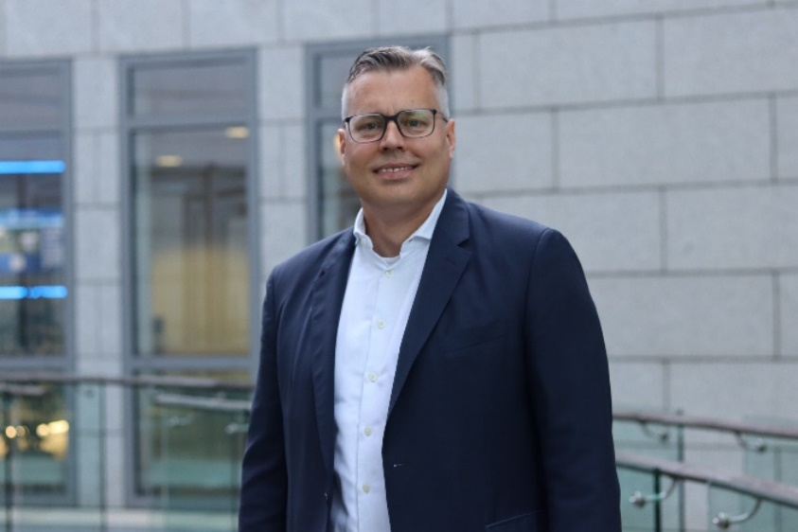

Graphic: MTP demo at the Industrial Transformation ASIA-PACIFIC (ITAP) show in Singapore in October 2023.
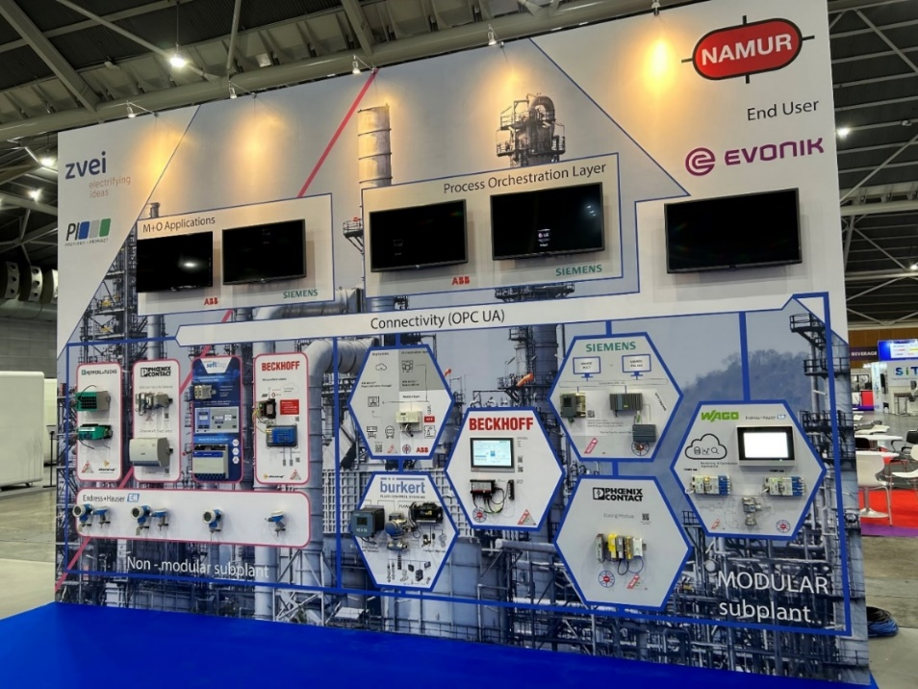

Press contact:
PI (PROFIBUS & PROFINET International)
PROFIBUS Nutzerorganisation e. V.
Barbara Weber

Ohiostr. 8

D-76131 Karlsruhe, Germany
Phone: +49 7 21 986197 49
Barbara.Weber@profibus.com
http://www.PROFIBUS.com

