P R E S S R E L E A S E

Cooperation Agreement Signed

Between mioty alliance and the IO-Link Community

Karlsruhe, Germany – April 16, 202x: The mioty alliance and the IO-Link Community (PI) have announced the signing of a major cooperation agreement at the Hanover Trade Fair.

This agreement will intensify cooperation between the two communication standards, especially with regard to data model use. The goal of this partnership is to enable the integration of mioty devices using the same mechanisms as those used for IO-Link devices. The advantage here is that users won’t need any new tools for mioty.

By combining the expertise of the mioty alliance in the development of wireless communication systems and the leading position of IO-Link in the area of industrial automation, this cooperation will set new standards. Both communities are convinced that this cooperation will bring about new and innovative solutions.

“We’re very pleased about our partnership with IO-Link. Together, we’ll shape the future of communication systems and offer our members even more powerful solutions,” said the mioty alliance’s General Manager Peter Hedberg in explaining the goals of cooperation.

“Cooperation with the mioty alliance will open up new opportunities for us to develop new applications and industries, especially in the area of IIoT and maintenance,” added Joachim Uffelmann of the IO-Link community.

Signing of the cooperation agreement was announced during the Hanover Trade Fair. Xaver Schmidt (Chairman of the Board of PI (PROFIBUS & PROFINET International)), Peter Hedberg (General Manager of the mioty alliance) and Joachim Uffelmann (Speaker of the IO-Link Steering Committee) are looking forward to the organizations’ cooperation. “Work on the specifications can now begin,” affirmed Joachim Uffelmann.

About the mioty alliance
The mioty alliance is a community of companies, institutions and developers who have dedicated themselves to creating and distributing the most accessible, robust and efficient IoT connectivity solution on the market. mioty technology is founded on a software-based low-power wide-area network (LPWAN) protocol developed specifically for massive industrial and commercial IoT applications. Thanks to its reliability and scalability, mioty technology enables robust wireless connectivity which meets the requirements of Industry 4.0.

About IO-Link
IO-Link is a globally open standard for point-to-point communication between sensors and actuators in industrial applications. IO-Link enables the bidirectional data exchange between a typical fieldbus gateway and the connected devices, which enables improved diagnostics, parameter setting and maintenance. With its strong commitment to innovation, IO-Link remains at the forefront of technological development and continually sets new standards in the industry across the globe. IO-Link is a technology of PI (PROFIBUS & PROFINET International).

***

Graphics: The cooperation agreement between the mioty alliance and the IO-Link community offers users a whole host of advantages. Joachim Uffelmann (Speaker of the IO-Link Steering Committee), Peter Hedberg (Managing Director of the mioty alliance) and Xaver Schmidt (Chairman of the Board of PI (PROFIBUS & PROFINET International)) are looking forward to the organizations’ cooperation (from left to right).
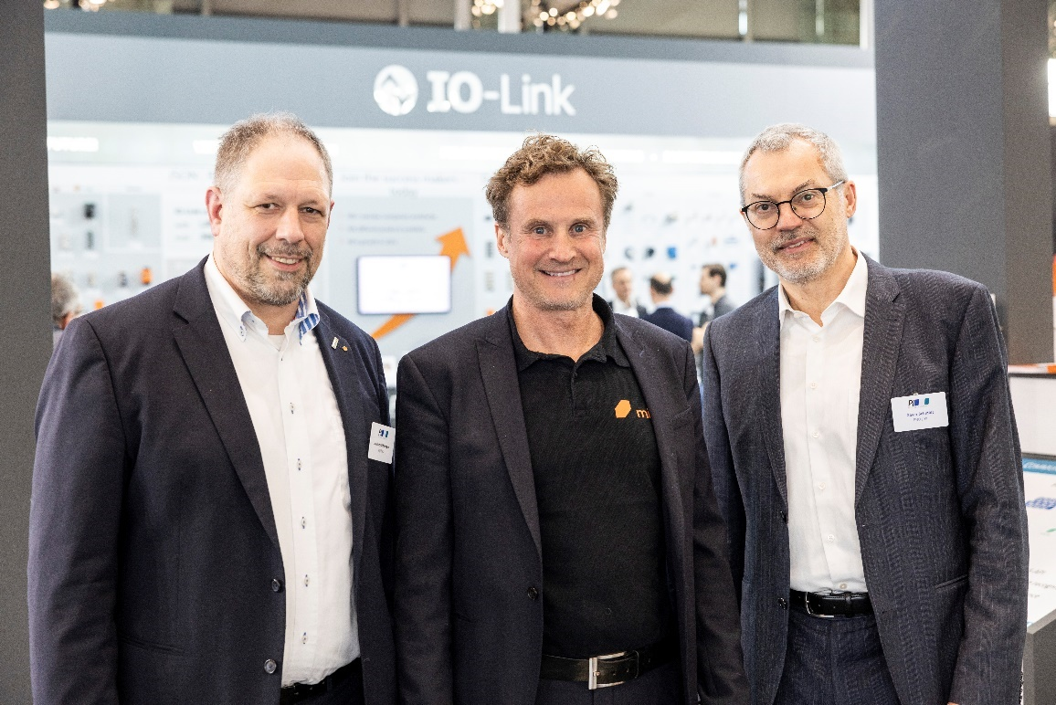
Press contact:
PI (PROFIBUS & PROFINET International)
PROFIBUS Nutzerorganisation e. V.
Barbara Weber

Ohiostr. 8

D-76149 Karlsruhe, Germany
Phone: +49 7 21 986 197 49
Barbara.Weber@profibus.com
http://www.profibus.com
This press release is available for download at www.profibus.com.

