P R E S S R E L E A S E

PI Technologies Hold Their Ground in the Current Economic Situation

Karlsruhe, Germany – March 31, 2025: The annual survey of newly installed nodes conducted by PI (PROFIBUS & PROFINET International) shows moderate growth for its technologies compared to previous years. Even in times of economic and structural change, PI technologies are experiencing solid growth for use in machines and systems across the globe. Economic uncertainties and the impact of supply issues on inventories naturally affect products with PI technologies as well, and this is reflected in device numbers accordingly - in particular in Europe and China. Despite this, products based on PI technologies were able to hold their ground well in the marketplace, which was impressively demonstrated by the number of newly installed nodes, though it was not possible to repeat or exceed the record numbers seen in previous years.

In 2022, disruptions in the supply chain led to material shortages and significant delivery bottlenecks. These limitations were more than compensated for in 2023 thanks to the supply of a very large number of IO-Link devices, which led to an anticipated normalization in 2024 with an additional 9.7 million new nodes having been put on the market. IO-Link remains stable and has been growing continually for years, with 61 million nodes at last count. IO-Link continues to successfully establish itself as a global standard.

This kind of trend can also be seen with PROFIsafe nodes. Following exceptional growth in the preceding year, an additional 3.1 million nodes were put on the market in 2024. The establishment of this safety technology from PI therefore remains unwavering and underscores its significance and acceptance in the industrial sector with 28.7 million PROFIsafe devices at the current time.

Despite challenging market conditions, PROFINET was able to maintain its strong position as a leading technology in 2024. With an increase of 9.5 million nodes, PROFINET boasts a high degree of continuity even in this challenging environment. This underscores the success and continuing demand for PROFINET in industrial applications. Altogether, an impressive 78.8 million PROFINET products have been installed in facilities over the years.

Unsurprisingly, the recorded growth in the number of PROFIBUS devices is moderate. Despite this trend, PROFIBUS’ share in the process automation market remains strong. In 2024, a total of 1.1 million PROFIBUS devices were sold - 800,000 of which in the process industry. This demonstrates the continuing relevance and reliability of PROFIBUS in this important sector. A total of 70 million PROFIBUS devices were brought to the market, with 17.3 million of them having been installed at processing plants.

“We see the trend in automation technology as positive, and we are ideally equipped for the future thanks to the continuous development of our technologies as the digital transformation progresses. The economic outlook is set to improve, and that includes international markets. Our globally distributed organizational form reinforces the market success of products with PI technologies. The demand for more data can be satisfied easily and consistently thanks to the PROFINET architecture and thanks to the extensive standardization of data structures and the consistent integration of IO-Link. With PROFINET over APL and PROFINET over SPE, we are leading the way in the introduction of APL/SPE technology. The first APL systems are already being put into productive operation, and we are supporting our manufacturers and users in using this new technology. In this way, we are promoting innovation and growth in automation applications across all industries through many activities,” remarked Xaver Schmidt, Chairman of PI (PROFIBUS & PROFINET International).

***

Graphic: PROFINET devices are growing continuously on the market.
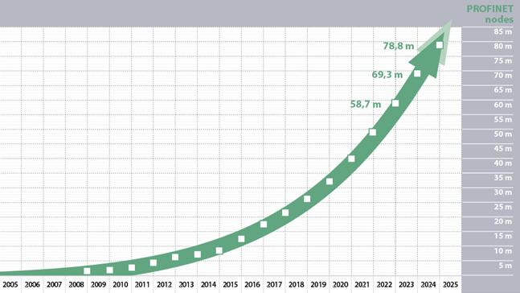

Graphic: The trend towards more data from actuators and sensors using IO-Link is unwavering.
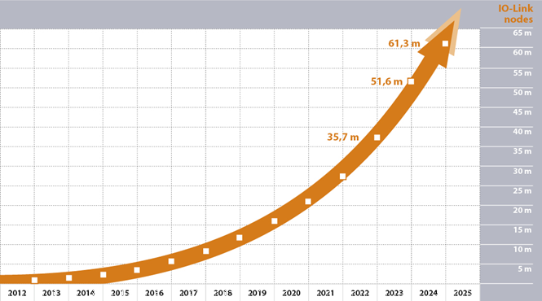

Press contact:
PI (PROFIBUS & PROFINET International)
PROFIBUS Nutzerorganisation e. V.
Barbara Weber

Ohiostr. 8

D-76149 Karlsruhe, Germany
Phone: +49 7 21 986 197 49
Barbara.Weber@profibus.com
http://www.profibus.com
This press release is available for download at www.profibus.com.

