P R E S S R E L E A S E

Strong Foundation, Clear Direction:
PI Continues Growth in Automation

Hannover – 20.04.2026: PI (PROFIBUS & PROFINET International) anticipates a noticeable upturn in the global automation market in 2025. The economic recovery in many regions is clearly reflected in the current node figures and marks a significant improvement over 2024. The broad technological portfolio—ranging from motion control to factory and process automation—has a stabilizing effect and effectively buffers regional and industry-specific fluctuations. At the same time, this diversity provides users and manufacturers with additional flexibility and creates robust, internationally viable market opportunities. Overall, PI technologies have once again proven highly successful and continue to record steady growth.

IO-Link maintains its strong market position and remains a key growth driver at the sensor and actuator level. In 2025, approximately 9.7 million new IO-Link devices and master ports were installed worldwide. This brings the total number of IO-Link nodes installed globally to 71 million. This development once again underscores the high level of industrial acceptance and the continuous spread of the standard across all industries. Following the particularly high volumes of previous years, the market is now entering a phase of normalization at a still very high level.

IO-Link benefits from its key role in end-to-end digitalization, from the sensor all the way to higher-level IT and cloud structures. Topics such as transparency at the field level, easy integration, standardized data models, and seamless integration into higher-level systems like PROFINET make IO-Link an indispensable enabler for data-driven automation, condition monitoring, and AI-supported applications. With new extensions such as IO-Link Safety, wireless approaches, and further-developed profiles, the range of applications is continuously expanding and creating additional momentum for future growth.

PROFINET continues its growth trend and is clearly benefiting from the general market recovery. With 10.4 million newly installed nodes, the total installed base has risen to 89.2 million. This steadily increasing adoption demonstrates how firmly PROFINET is established in a wide variety of industrial scenarios. At the same time, this broad installed base provides a stable foundation for upcoming digitalization steps: from end-to-end data communication with IO-Link integration to increasing security requirements and the transition to Gigabit network technologies. As a result, PROFINET is increasingly becoming a key enabler for AI-supported automation and remains a central building block of modern, scalable production systems.

For PROFIBUS, the expected gradual decline in new installations is confirmed, though without any abrupt changes. In the current year, 1 million devices were commissioned, bringing the total to 71 million. In process automation, 700,000 new PROFIBUS PA devices were commissioned, increasing the total to 18 million. The decline is directly linked to the technological transition to Ethernet-APL, which continues to gain momentum. At the same time, the still high number of newly installed devices shows that PROFIBUS continues to play a significant role in many plants—particularly in long-running processes, expansions, and replacement projects.

PROFIsafe continues to develop positively and is stabilizing at a high level. With 2.8 million new nodes added, the installed base has grown to 31.5 million. The consistently high number of new installations underscores the strong industrial acceptance of PROFIsafe as a reliable safety technology in modern automation systems.

“Our technologies provide a reliable foundation for further growth, even in a dynamic environment,” says Xaver Schmidt, Chairman of PI (PROFIBUS & PROFINET International). “Challenges such as security, rising data volumes, and energy efficiency demonstrate how important robust and widely recognized automation solutions are—solutions that remain easy to implement at the same time.”
With end-to-end communication solutions from the sensor to the cloud, PI already enables a simple and cost-effective entry into AI-supported automation. At the same time, the technological foundation is being consistently further developed.

“With the PROFINET V2.5 specification, completed this year and fully backward compatible, we are significantly strengthening this foundation: New functions can be easily combined with existing installations,” explains Schmidt. “The rollout of Ethernet-APL continues to gain momentum and is effectively complemented by Single Pair Ethernet. We are also driving important innovations in the IO-Link environment—for example, with IO-Link Safety, Wireless, and profiles that further expand the technology’s capabilities.”

PI thus offers a comprehensive, optimally coordinated technology portfolio that provides both users and manufacturers with long-term investment security and clear guidance. “In this way, we are laying the foundation for sustainable growth across all industrial sectors and remain a reliable technology partner and innovation driver for our global community,” Schmidt affirms.

***

Graphic: PROFINET devices are growing steadily in the market.

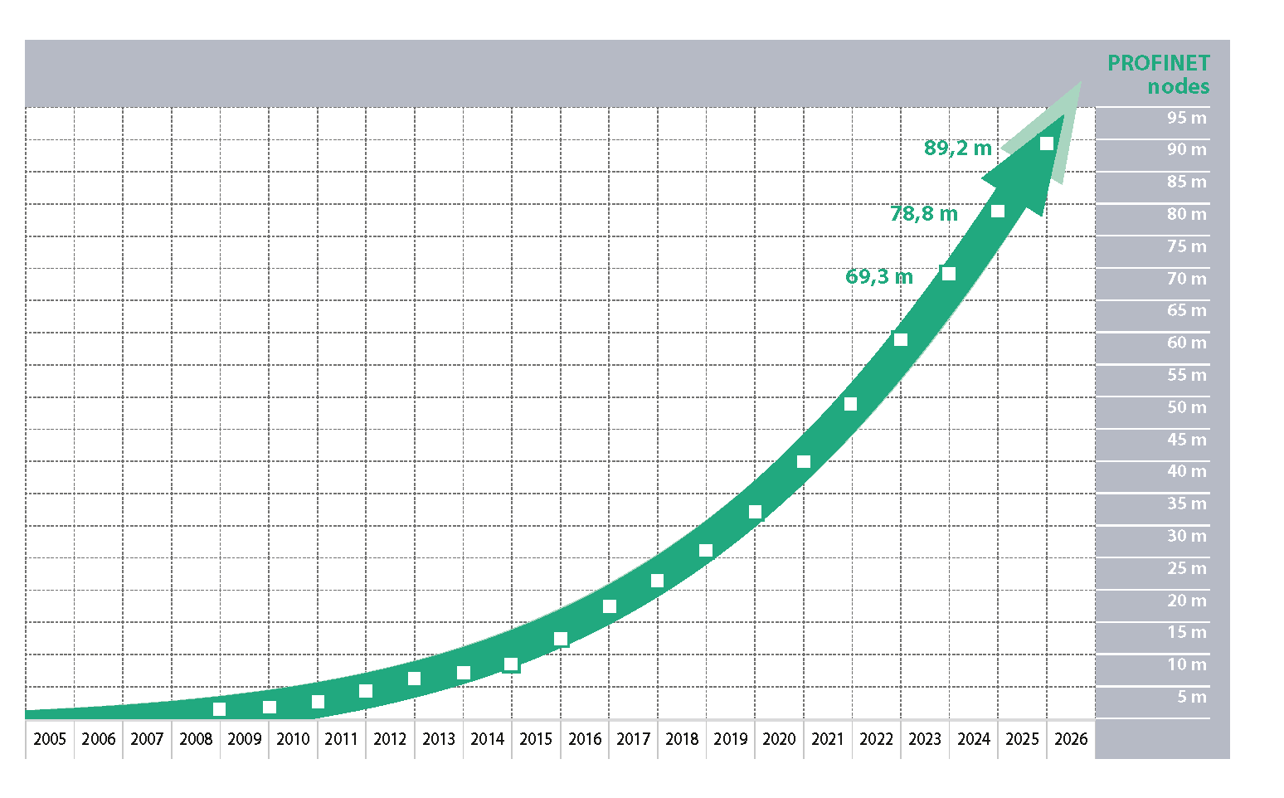

Graphic: The trend toward more data from actuators and sensors via IO-Link continues unabated.

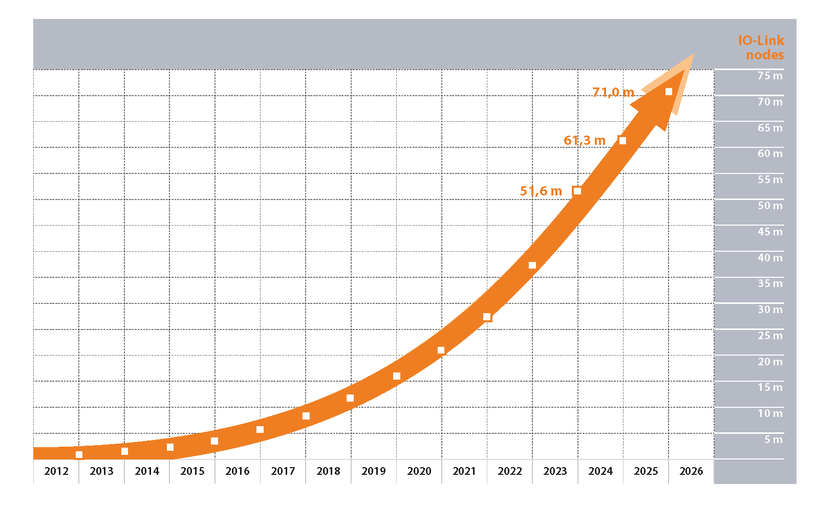

Press Contact:
PI (PROFIBUS & PROFINET International)
PROFIBUS Nutzerorganisation e. V.
Barbara Weber

Ohiostr. 8

D-76149 Karlsruhe, Germany
Phone: +49 7 21 986 197 49
barbara.weber@profibus.com
http://www.profibus.com

