P R E S S E M I T T E I L U N G

IO-Link Safety Reaches Important Milestone:
TÜV SÜD Certifies Specification

Karlsruhe, August 11th, 2025: The IO-Link Community has reached a significant milestone in the further development of IO-Link Safety: TÜV SÜD has successfully tested and officially certified the IO-Link Safety specification V1.1.4. This lays the foundation for the widespread industrial use of the technology-neutral safety solution.

Certification by an independent testing agency marks the end of the development phase for IO-Link Safety and now enables the introduction of market-ready products. As the first officially designated IO-Link Safety Test Center, TÜV SÜD has already begun testing IO-Link Safety masters and devices. The first certified products will be available on the market shortly.

IO-Link Safety is the safety-related extension of the proven IO-Link technology and enables – in line with the IO-Link concept – seamless integration into existing automation and safety structures. The specification was already positively evaluated by TÜV SÜD and the Institute for Occupational Safety and Health of the DGUV (IFA) during the concept phase. Based on the proof-of-concept results, the specification was consistently developed further to product maturity together with the associated test specification.

In contrast to conventional IO-Link, IO-Link Safety relies on third-party certification. Manufacturers must have their products tested at a recognized test center—an additional step to ensure the highest quality and safety standards.

With over 20,000 IO-Link-compatible products available and more than 500 manufacturers worldwide, IO-Link offers a dynamic ecosystem that creates ideal conditions for rapid market penetration of IO-Link Safety. The open architecture enables easy integration into all common PLC, DCS, and IoT systems. Development costs are particularly high when it comes to functional safety, which makes it all the more valuable that IO-Link Safety requires support for only a single, easily implementable communication standard. As IO-Link Safety devices can be used in all automation systems worldwide without modification, which is why the community expects rapid establishment and fast market growth.

***

Graphic: IO-Link Safety is now certified – the TÜV SÜD seal paves the way for safe practical use.
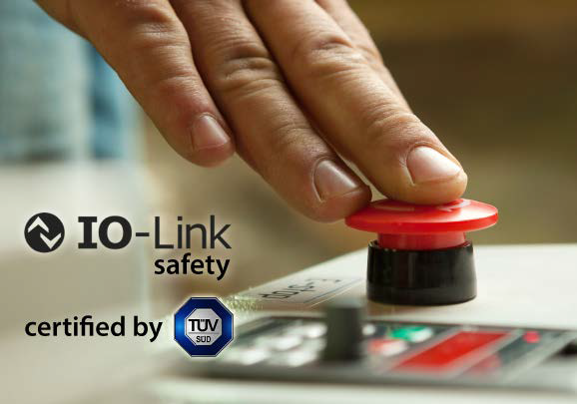
Copryright: Adobe Stock Foto luckyraccoon/123RF

Press Contact:

PI (PROFIBUS & PROFINET International)

PROFIBUS Nutzerorganisation e. V.

Barbara Weber

Ohiostr. 8

D-76149 Karlsruhe
Tel.: ++49 7 21 /986 197 - 49
Barbara.Weber@profibus.com
http://www.profibus.com
Diese Pressemitteilung liegt unter www.profibus.com zum Download für Sie bereit.

