P R E S S R E L E A S E

Certified PROFINET over APL Products in Field Tests with End-Users
First certificates issued for position controllers

Karlsruhe, 10. October 2025: The functionality of PROFINET for explosion-proof applications in process automation is available in its complete scope. In joint working groups, experts from PROFIBUS & PROFINET International (PI) are currently working closely with end-users to intensively evaluate the potential for use and interoperability of PROFINET over APL products from different manufacturers in several pilot plants in the chemical industry. The basis for a high degree of interoperability is a certification test for all product types, including controllers, sensors, actuators, and switches. Tests for actuators have been added to the latest version of the PROFINET Test Bundle. The first products have already successfully passed the certification tests. For example, Samson has received the first certificates for its positioners.

"In addition to developing user-friendly technology and establishing targeted measures for product quality assurance, we believe that working with users is an important step in establishing the technology in plants and promoting its acceptance. For years, we have been working closely with users throughout the entire life cycle of technology. This begins with the creation of requirements and extends to the evaluation of prototypical or real products in pilot or demo systems. The experience gained in this process is incorporated into the maintenance and further development of our technologies," says PI Chairman Xaver Schmidt.

In addition to physical layer tests to verify suitability for intrinsically safe applications, the scope of certification testing for PROFINET over APL products includes additional APL-specific test cases for verifying PROFINET communication, the execution of an APL-specific test setup for interoperability scenarios, and tests for the Profile for PA Devices. With the availability of certification for actuators, the PI experts for PROFINET over APL have completed another step toward deployment in process automation.

In the meantime, end-users have positively evaluated the suitability of PROFINET over APL with certified products in several test lab installations. PI has initiated activities involving PI experts and users from the process industry to define further field tests. These will also be extended to the topic of security, considering the underlying non-Ethernet communication systems.

In addition, the topics of functional safety with PROFIsafe and the certification of switches are on PI's agenda, which are also being developed in close cooperation with end-users from the process industry.
***
Graphic: Certification is now available for all device types with PROFINET over APL.

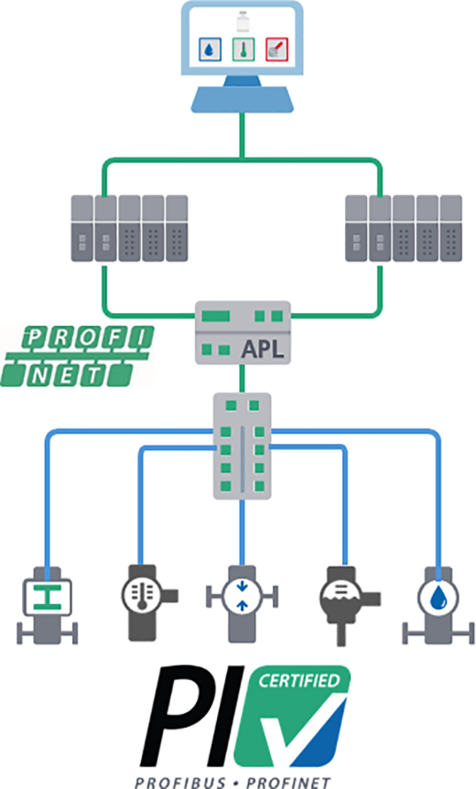

Press Contact:
PI (PROFIBUS & PROFINET International)
PROFIBUS Nutzerorganisation e. V.
Barbara Weber

Ohiostr. 8

D-76149 Karlsruhe
Tel.: +49 7 21 /986197 - 49
Barbara.Weber@profibus.com
http://www.profibus.com

