P R E S S R E L E A S E

10 Years PROFINET Tester - „Best in Class”
Karlsruhe –October 22, 2025: The PROFINET Tester is the central testing tool for verifying the conformity and interoperability of PROFINET devices. It is used by PI (PROFIBUS & PROFINET International) test laboratories worldwide for official certification tests and is available to all PI member companies to validate their own developments during implementation. This makes the tester an essential component in ensuring the quality and reliability of the global PROFINET device base. In 2025, the test system will celebrate its tenth anniversary: the first official version was made available to PI members in 2015. The tester has established itself as an indispensable tool for manufacturers, integrators, and testing institutes, and countless certified PROFINET devices have been tested with its help since then. It thus makes a significant contribution to ensuring reliable and interoperable operation in a wide range of applications in machines and plants.

The starting signal was given in December 2013 during a PI Advisory Board meeting. The test program at that time no longer met the requirements for fully automated test execution and evaluation. The current PI Chairman, Xaver Schmidt - then head of the PROFINET Marketing Working Group - presented the need and requirements for a modern test system that could be used both in the PI test laboratories for certification tests and in the development departments of companies implementing PROFINET interfaces. Top quality is crucial for users and a basic requirement for manufacturers during implementation, and therefore crucial for success. In addition to the long-term, continuous development of the test system—driven by the functional expansion of the PROFINET specification—the highest possible degree of automation played a central role. This ensures a consistently high level of quality worldwide and optimizes the effort and processes in the development departments.

The test system is officially updated annually, with quarterly trial versions and technology packages for defined features. Additional plug-ins are common when new features are introduced. This established procedure has proven itself in the PI community and supports coordinated further development. The PROFINET Tester has become an integral part of development and testing departments worldwide. The response to regularly offered tester webinars is remarkable – both in terms of technical discussion contributions and participant numbers. Funding is provided by certificate fees and membership fees, as well as additional financial and content contributions from some member companies. The PROFINET Tester is available exclusively to members as a free download at www.profibus.com as part of the test bundles. Ten years of PROFINET Tester stand for continuous innovation, close cooperation, and a strong foundation for the future of industrial communication.
***
Graphic: The PROFINET Tester is celebrating its tenth anniversary in 2025. It has established itself worldwide as the central testing tool for checking the conformity and interoperability of PROFINET devices.

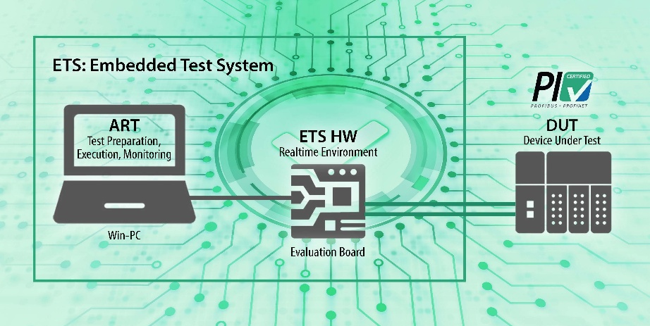

Press contact:
PI (PROFIBUS & PROFINET International)
PROFIBUS Nutzerorganisation e. V.
Barbara Weber

Ohiostr. 8

D-76149 Karlsruhe, Germany
Phone: +49 7 21 986197 49
Barbara.Weber@profibus.com
http://www.profibus.com

