PRESS RELEASE

PROFIBUS & PROFINET International publishes MTP Specification 2.0

Karlsruhe, January 20, 2026 – PROFIBUS & PROFINET International (PI) announces the official release of Module Type Package (MTP) Specification 2.0. The significant functional enhancements in the new version of the standard represent an important milestone for modular automation. MTP 2.0 lays the foundation for true interoperability, even greater flexibility, and efficiency in the planning, integration, and operation of modular systems across all industries.

Following successful final coordination of the content by the expert groups of the three supporting organizations PI, NAMUR, and ZVEI, the specification documents were made available for approval. With the decision to publish by the MTP Steering Committee of the three supporting organizations, the specification is now available for implementation in industrial products and applications.

The development of MTP 2.0 was actively supported by numerous international companies. Various experts from user, manufacturer, and engineering companies contributed to joint working groups. This broad participation underscores the high relevance of the standard and the strong interest of the industry in a sustainable, standardized solution for modular production concepts.

The necessary rights of use for the MTP Specification 2.0 are available to member companies as usual. This ensures that companies can integrate the standard into their products, engineering tools, and plant concepts without additional hurdles.

The new version of the standard has not only been further developed conceptually, but has also already been tested in practice: Several member companies have implemented MTP 2.0 and successfully tested it in a plugfest. The results confirm the interoperability of the solutions and the applicability of the specification in real industrial environments.

MTP 2.0 implements key enhancements and improvements over previous versions. These include further optimized interoperability between the plant level and control systems, functional enhancements, and a clear focus on future requirements of the process industry. Thanks to consistent further development, MTP 2.0 can be used across a wide range of industries, from the chemical and pharmaceutical industries to food & beverage and other industrial sectors.

With the release of MTP 2.0, PI is sending a clear signal about the relevance of modular automation and underlining its commitment to working with industry to develop open, practical, and future-proof standards.

***

Graphic: MTP 2.0 sets new standards for modular automation – interoperable, flexible, and proven in practice for industrial use.
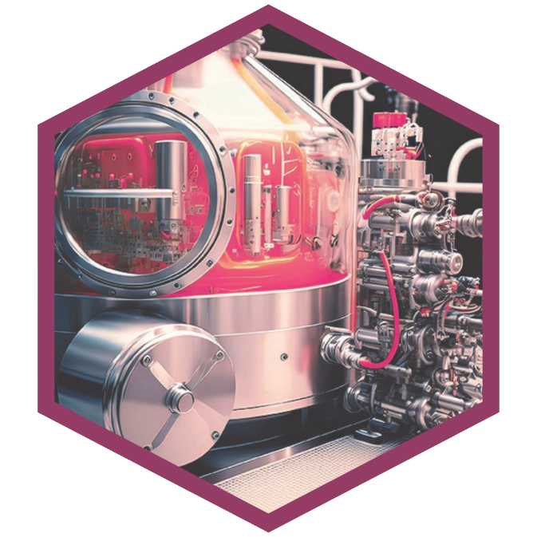
Copyright: © pixardi / stock.adobe.com

Press contact:
PI (PROFIBUS & PROFINET International)
PROFIBUS User Organization e. V.
Barbara Weber

Ohiostr. 8

D-76149 Karlsruhe
Tel.: +49 (0)7 21 /986197 - 49
Barbara.Weber@profibus.com
http://www.PROFIBUS.com

