P R E S S R E L E A S E

First MTP V2.0 Plugfest successfully completed
An important step for interoperability in process automation

Karlsruhe - Germany, October 27, 2025: The MTP Committee has successfully held the first plugfest based on the new MTP V2.0 specification. The aim of the event was to test the interoperability and functionality of the new version in practice.

Six future MTP providers participated with five Process Orchestration Layer (POL) and six Process Equipment Assembly (PEA) solutions. Among other things, the import of MTPs and the quality of the import, the runtime compatibility between POLs and PEAs, and workflows set up directly with MTP through ad hoc combinations were tested.

The tests were successful and showed significant progress in interoperability. The new content and corrections to the specification confirmed the high degree of maturity and practicality of MTP V2.0. It was particularly positive that all test setups could be put into operation quickly and smoothly – a clear indication of the increasing technical stability of the technology.

“The plugfest was an important milestone for the quality assurance and further development of MTP,” emphasized the MTP Committee. “The results confirm that MTP delivers what it promises: easily merging automated systems and creating executable solutions.”

The committee would like to thank all participating companies and experts for their dedicated cooperation and open exchange. The shared interest of NAMUR, ZVEI, and PI (PROFIBUS & PROFINET International) underscores the close integration of users, manufacturers, and standardization bodies in the further development of MTP. Further plugfests are already being planned to further consolidate implementations and deepen interoperability.
About MTP: The Module Type Package (MTP) is a standardized concept for the automated integration of automation systems. It enables the easy combination and reuse of automated equipment from different manufacturers, thus forming a basis for flexible, scalable, and interoperable production processes.
***

Foto: Group photo of the first MTP V2.0 plugfest.
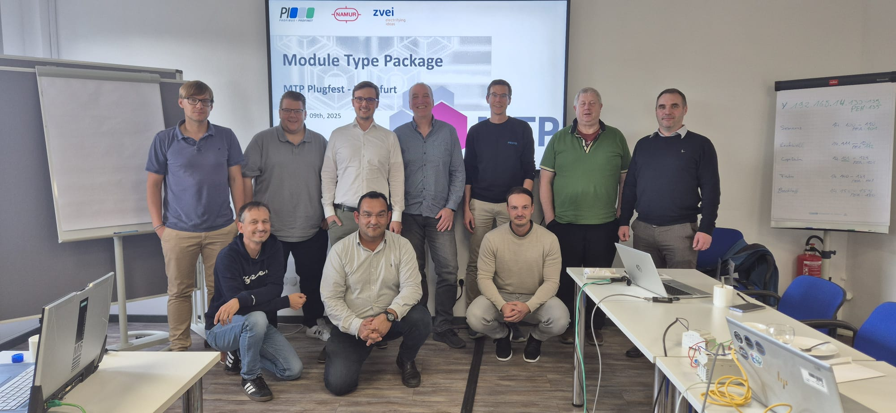
Grafik: Plugfest participants test the usability of MTP V2.0.
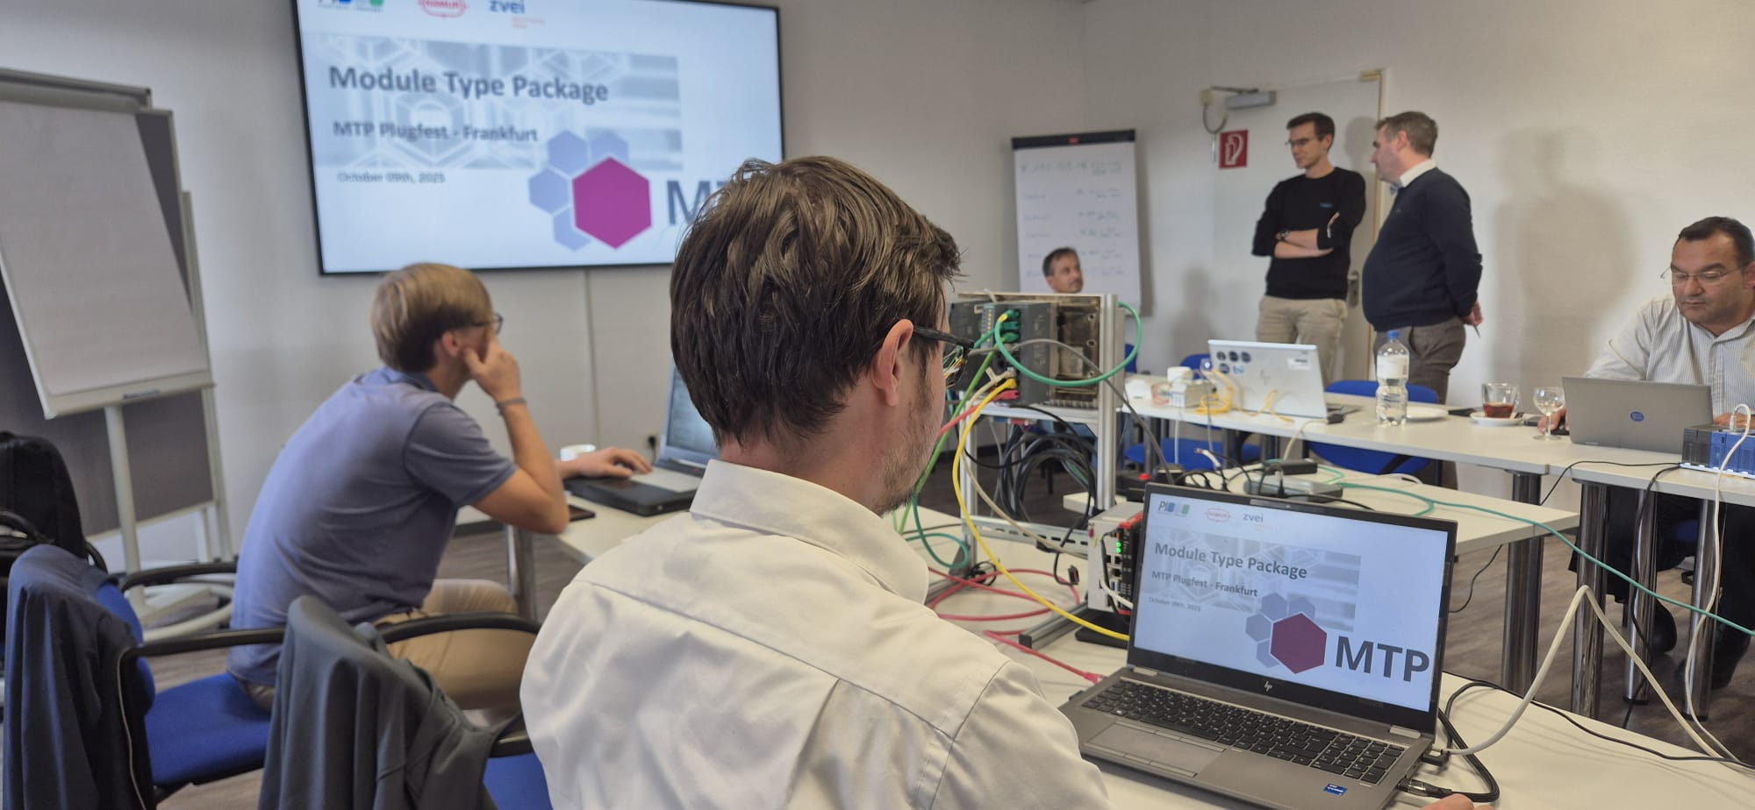

Press contact:
PI (PROFIBUS & PROFINET International)
PROFIBUS Nutzerorganisation e. V.
Barbara Weber

Ohiostr. 8

D-76149 Karlsruhe, Germany
Phone: +49 7 21 986197 49
Barbara.Weber@profibus.com
http://www.PROFIBUS.com

