P R E S S R E L E A S E

New Dates Set For "IO-Link Safety Certified Designer" Training

Karlsruhe, Germany – July 30, 2024: The IO-Link Community is once again offering an IO-Link Safety Certified Designer training course together with TÜV SÜD Rail from November 26 through 28, 2024. With IO-Link Safety, automated machines and system can now be enhanced with functionally safe components and communication through IO-Link as well. Training is held in English in Karlsruhe (Germany) and conveys in-depth understanding of the new technology and the general principles of safety technology. After passing the test, the participants will receive their own personal TÜV certificate.

The content of the first day of training will include the principles of IO-Link Safety, e.g. function and design, safety principles, functional objectives, IO-Link requirements ("black channel") and both risks & the measures for avoiding them. The topics of communication protocols, diagnostics, device replacement without tools, configuration, parameterization & backup of data, possible architectures, testing & certification, EMC requirements and application examples will also be covered.

On the second day, TÜV SÜD Rail will cover the basics of safe development—of FS masters and FS devices in particular—in accordance with IEC 61508/62061 and ISO 13849, enabling participants to assess the requirements for their own engineering departments. This includes an overview of the relevant standards & their content, project management, management for functional safety, required documentation, life cycle, safety functions, preferred architectures, methods for avoiding dangerous faults, FMEA, verification & validation and certification.

On the third day, a general overview of the procedures for design & implementation and testing of IO-Link FS masters and IO-Link FS devices, as well as the creation of IODDs and dedicated tools, will be provided. This will be followed by a practical demonstration of various testing tools required for development and the presentation of available technology components and services.

A written test is administered following the completion of each day's training. All three tests must be passed in order to receive a certificate. A participation fee of 700 Euros is charged for the course. For more information and online registration, visit:
www.io-link.com.
***

Graphic: IO-Link Safety expands machines and systems automated with IO-Link to include functionally safe components and communication. IO-Link Safety Certified Designer training conveys in-depth understanding of the new technology.

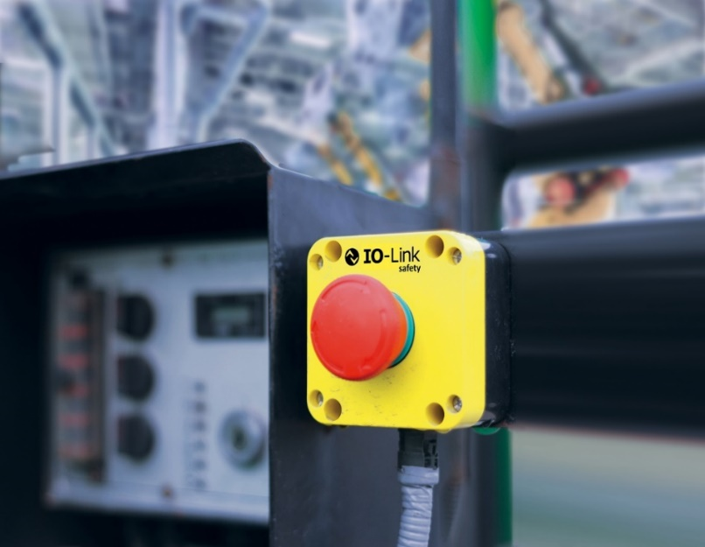

Press contact:
PI (PROFIBUS & PROFINET International)
PROFIBUS Nutzerorganisation e. V.
Barbara Weber

Ohiostr. 8

D-76149 Karlsruhe, Germany
Phone: +49 7 21 986197 49

Fax: +49 7 21 986197 11
Barbara.Weber@profibus.com
http://www.profibus.com
The text of this press release is available for download at www.profibus.com.

